Disincentive IRI Ride, Item 804.4410 – Example DT1310 (NER20-1202)
- Bid Item Name:
Disincentive IRI Ride, Item 804.4410
- Quantity Involved:
Enter dollar amount of disincentive (include the negative sign)
- Units:
DOL
- Test Results:
See Disposition Explanation
- Spec Requirements:
Select appropriate requirements:
SS 740 – CAT Type: HMA I
IRI < 60 in/mi
LR < 200 in/mi

SS 740 – CAT Type: HMA II / PCC II
IRI < 85 in/mi
LR < 200 in/mi
- Disposition Explanation:
IRI Operator: Brandon Belly (HTCP #101101), Asphalt Binder Co
IRI and localized roughness were reported in the IRI Ride Summary and confirmed by the contstruction team independently by physically driving the project. Data was reviewed and pay was adjusted according to SS 740.5.2 Areas of IRI and locations of localized roughness were found at:

IRI:
NB LN 1 RWP 65.50 in/mi (-$91.67)
NB Pass LN LWP 86.00 in/mi (-$129.50)

Localized Roughness:
NB LN 1 RWP 246.90 in/mi (-$250.00)
SB LN 1 RWP 213.70 in/mi (-$82.20)
SB LN 1 LWP 219.30 in/mi (-$212.30)

Disincentives are applied in CCO #4.
- Placement Date:
Enter date profiled. (If profiled on multiple dates, use the first date)
- Sample Date:
Leave Blank
- Sample Location:
Highway Route and cardinal direction(s)
STH 22 NB / SB
- Usage:
Select One:
HMA Pavement
Concrete Pavement
- Usage Location:
Choose appropriate requirements:
Posted Speed >= 55 mph
Posted Speed < 55 mph

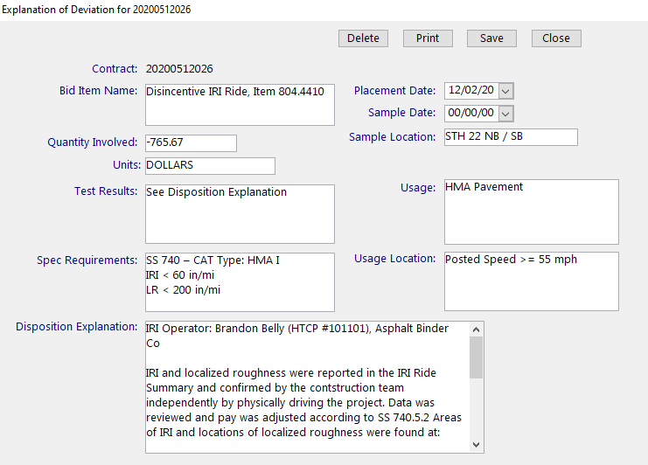
Figure: MIT Entry Disincentive IRI Ride Example

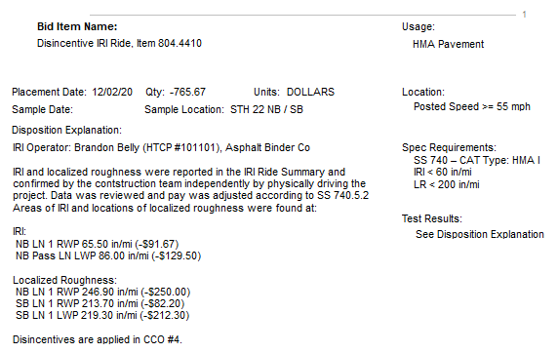
Figure: Printed DT1310 Disincentive IRI Ride Example

